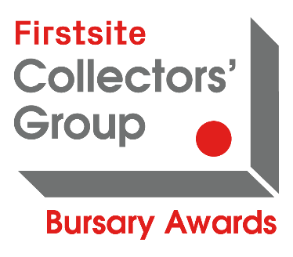
Firstsite Collectors’ Group Bursary Awards 2022
Application Form

The deadline for applications is 10am, Monday 12 December 2022.
Please email your completed application to opportunities@firstsite.uk
As an alternative to completing this application form, you can submit picture or flow diagrams, a 5 minute (or less) raw video or audio files in response to the questions below. Should you require any further information or guidance on completing an application please email opportunities@firstsite.uk
Name:

Address:

Telephone:

Email:

Website:

Social media accounts:

Artist statement (no more than 250 words)
Please describe your current work and research interests

Project/activity description (no more than 600 words)
Please describe what you would do with the Firstsite Collector’s Group Bursary Award.
For example, where relevant-
- Describe studio or project activities, exhibitions, research trips, outcomes
- Professional development, mentoring, learning new skills, exploring new mediums, visiting events

Development (no more than 250 words)
Please describe how this award would benefit you and/or your practice

Please insert images of 3 examples of your work INTO this application form, rather than attaching image files into your email when submitting your application. Please include web links if your work is film/ hosted online.
1.

2.

3.

How much money are you requesting: £

The maximum award considered is £1,000. However, please note that the typical value of award is between £100 and £500.

Please attach a budget detailing expenditure and any other sources of income you have applied for or expect to receive.
Have you applied to the Firstsite Collectors’ Group Bursary Awards before?

If you are a first-time applicant, how did you find about the Bursary Awards?

Please email your application to opportunities@firstsite.uk by 10am, Mon 12 December 2022

