Firstsite Open Call ‘Voyager 2000’ Submission Form

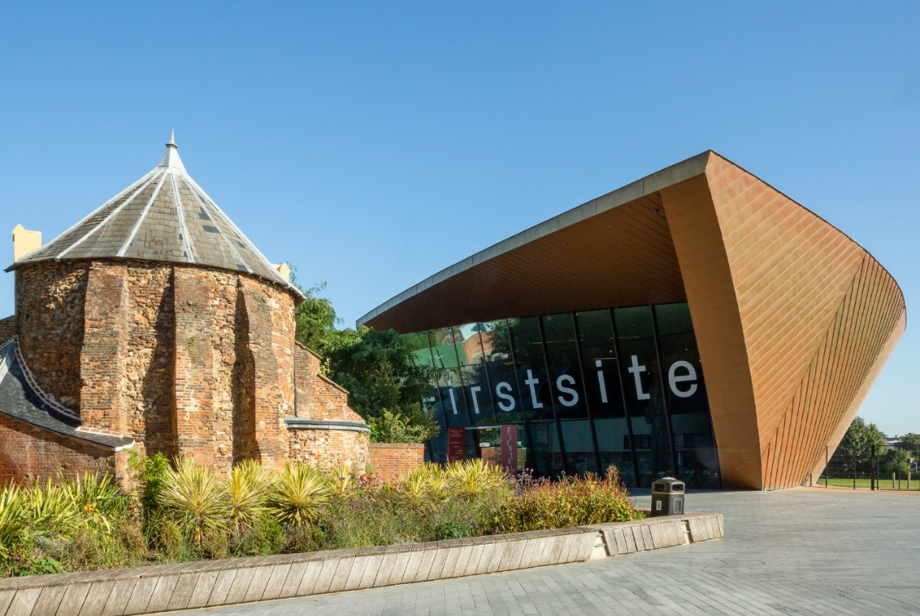

How to submit:
Please complete this form and submit in one of the following formats:
- word document or pdf
- picture collage
- audio or video file (no more than 5 minutes in total)
Please email your application to opportunities@firstsite.uk
Deadline: 2 March 2025 17:00
Outcome: We expect to notify by 4 April 2025
Name:
Postcode:
Telephone:
Email:
Briefly describe what your work explores and how this relates to technology, communication, human connection, and imagination; (up to 200 words)
Add images of up to 5 examples of your work or website links for films, INTO this application form
Have you exhibited at Firstsite before?
If you are under 16 do you have permission from a parent or caregiver to submit this form?
As part of our commitment to inclusivity, please declare any of the following.
Do you have personal or social connection with a Firstsite member of staff, trustee, member of the Collectors’ Group?
Have you previously been awarded/or awarded funds by/to a Firstsite member of staff, trustee, member of the Collectors’ Group when they were working outside of their role at Firstsite?
Do you deliver workshops or events at Firstsite?
If yes please give details.
Please provide any feedback here regarding this application form, including suggestions for improvement

