Firstsite Collectors’ Group Bursary Awards 2026
Application Form

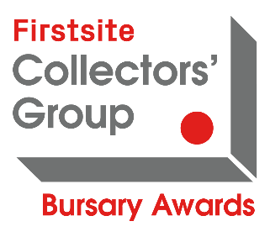

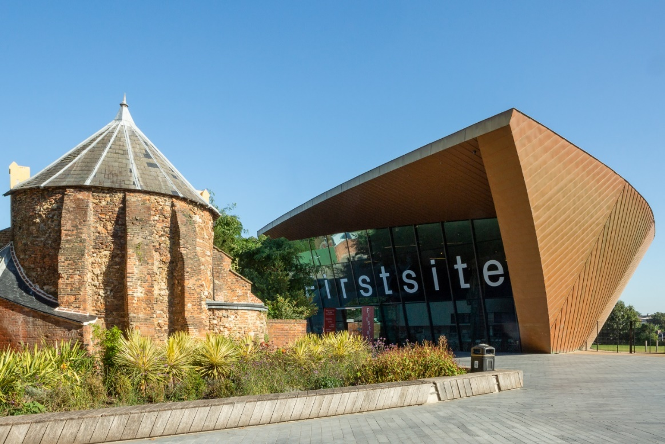

How to submit:
Please fill in this form, and send to us in the following ways:
- word document or exported pdf
- picture collage
- audio or video file (no more than 5 minutes in total)
Please email your application to opportunities@firstsite.uk
Deadline: 22 November 2026 17:00
Name:
Address:
Postcode:
Telephone:
Email:
Artist Statement (100 Words);
If you want to maybe include,
- What does your work explore?
- What materials do you use and why?
- And how do you want the audience to be impacted by you work?
Project (100 words); Please describe what you want to use the bursary for

Impact (100 words)
Think about the following reasons
- How will this bursary support you as an artist?
- How will this bursary bring about new developments in your work?
- Why do you need this bursary now more than ever?
Add images of 3 examples of your work or website links for films, INTO this application form
Amount requested: We consider awards between £100-£1000
Please write a budget and any other money or grants you have applied for or think you may get from anywhere else.
Have you applied to the Firstsite Collectors’ Group Bursary Awards before?
Have you received an award before, if Yes also please state the year;
Yes/No
If you are a first-time applicant, how did you find out about the Bursary Awards?
As part of our aim to support inclusivity, please tell us of any of the following;
Do you have personal or social connection with a Firstsite member of staff, trustee, member of the Collectors’ Group?
Have you previously been awarded/or awarded funds by/to a Firstsite member of staff, trustee, member of the Collectors’ Group when they were working outside of their role at Firstsite?
If yes, please write in what way.
Please write here any feedback you have on the form, or the award, including ways we can improve what we do.

